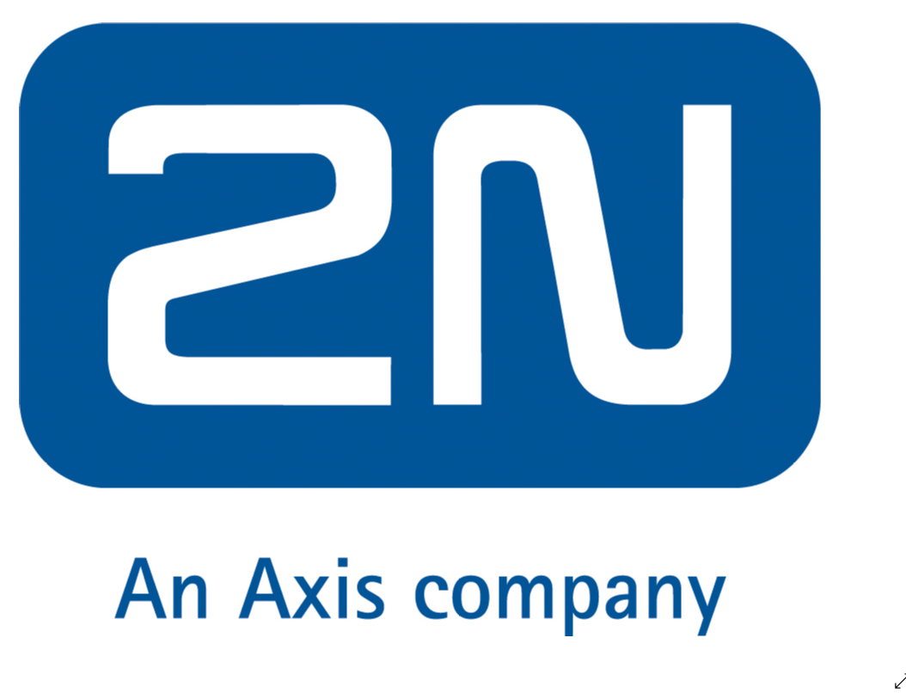 | UK and Sweden | Open Door to Innovations  2N is a significant innovator n the field of IP intercoms, access control systems and IP lift communications. This Czech-based company has more then 300 employees, 7 subsidiaries and distribution networks all over the world. In 2016 2N became a part of the Axis Group.  www.2n.cz  Contact:  T: 42 (0) 225 271 500  E: Sales@2m.cz
 | UK and Sweden | For more than 20 years, Advancis is successful on the market as an owner-operated company. With international representations as well as certified integration partners, the company is today one of the international market leaders in vendor-neutral security and building management.  Contact:  T: +44 7917 652321  E: sales@advancis.net
 | UK and Sweden | Transforming Video into Actionable Intelligence  BriefCam® is the leading industry’s leading provider of VIDEO SYNOPSIS® and Deep Learning solutions for rapid video review and search, face recognition, real-time alerting and quantitative video insights. By transforming raw video into actionable intelligence, BriefCam dramatically shortens the time-to-targets for security threats while increasing safety and optimizing operations.  www.BriefCam.com  Contact:  T: +972 2 533 7228  E: info-emea@Briefcam.com
 | UK and Sweden | Camstreamer  Will be showing three apps in action. Camstreamer will demo streaming to YouTube, embedded graphics (compass, weather,infoticker) and will show integration with AXIS door controller.  Contact:  T: +440 226 258 030  M: sales@camstreamer.com

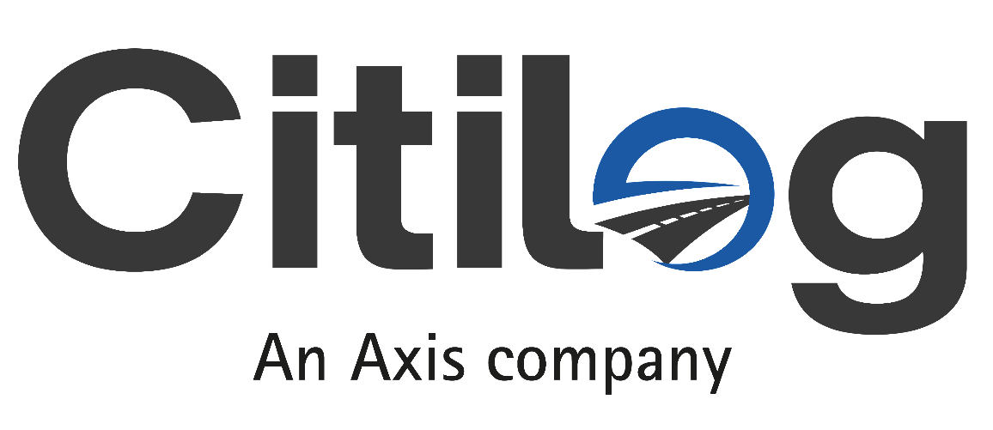 | UK and Sweden | Video Analytics Solutions for Traffic  Through video-based traffic management solutions for smarter mobility, Citilog contributes to roads where traffic moves safety and more freely. Ideally combined with Axis camera technology, Citilog traffic expertise enhances safety and traffic flow, which simplifies decisions and allows more to be done with existing infrastructure. Citilog is an Axis Communications group company.  Contact:  T: +33 1 40 96 38 03  E: eric.toffin@citilog.com/jmguyon@citilog.com
 | Sweden | Solution driven, pioneering facial recognition software  Customer Clever is a facial recognition software solution used for data collection and customer loyalty applications. Our highly secure systems can be used across many sectors and in a wide range of business solutions including access control, individual identification, customer intelligence and demographic data collection, customer participation studies, customer journey and retention solutions and VIP services.  Contact:  T: 01636 558930  E: info@customerclever.co.uk
 | UK and Sweden | Dedrone GmbH  Dedrone is the market and technology leader in airspace security. The Dedrone counter-drone platform combines hardware sensors and machine-learning software, providing early warning, classification of, and mitigration against all drone threats. Dedrone is headquartered in San Francisco, USA. Research and development are based in Kassel, Germany.  Contact:  T: + 49 561 861 799 0  E: info@dedrone.com  www.dedrone.com/contact

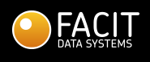 | UK and Sweden | Video analytics and compliance solutions  Facit Data Systems is a knowledge company that specialises in video and data analytics. We produce rigorously tested software that is intuitive to use that generates reliable, accurate and actionable data. Our senior management team combines academic rigour with many years of depth knowledge helping people in retail, banking, the public sector and other high football venues to deliver superior customer experiences and operational efficiencies.  Contact:  Chris Selwood  T: +44 (0)3700 610 498  E: info@facitdatasystems.com
 | UK and Sweden | Protecting the everyday  Genetec Inc, is an innovative technology company with a broad solutions portfolio that encompasses security, intelligence, and operations. Founded in 1997, and headquartered in Montreal, Canada, Genetec serves the global customer via an extensive network of resellers, integrators, certified channel partners, and consultants in over 80 countries.  www,genetec.com  Contact:  E: mrieger@genetec.com  T: +49 151 428 864 91
 | UK and Sweden | Ikusi Multimedia is expert in offering innovative and high technology solutions for the reception, processing and distribution of TV and video signals.  Contact:  https://www.ikusi.tv/en/contact

 | UK and Sweden | Leading Video Management Solutions  Milestone Systems is a leading provider of open platform video management software; technology that helps the world see how to ensure safety, protect assets and increase business efficiency. Milestone enables an open platform community that drives collaboration and innovation in the development and use of network video technology, with reliable and scalable solutions.  www.milestonesys.com  Contact:  E: SOH@milestonesys.com  T: +44 (0)7834 359821
 | UK and Sweden | Cloud Video Surveillance & Access Control  Morphean is a Swiss technology company with a strong presence in more than 12 countries worldwide, and with over 60 partners across Europe. With expertise across retail, transport and facilities management, among others, the company is recognised as a leader in secure services platform delivery through the use of cloud and AI technologies with key focus on Video Surveillance, Business Intelligence and Access Control. The platform helps firms prepare for the future by keeping their “Eyes Wide Open” to the intelligence gathered from a variety of network connected devices.  www.morphean.com  Contact:  T: + 41 26 422 00 90  E: info@morphean.com
 | Sweden | Computer Vision for Retailers  Neurolabs is a Machine Learning start-up, founded by a team of masters and PhD in AI. The core technology is based on a unique way of combining synthetic data generation and deep learning models to accurately recognise objects. Applications include on-shelf availability in supermarkets and cashier-less checkouts for canteens.  www.neurolabs.eu  Contact:  T: +44 (0)7444058980  E: hello@neurolabs.eu

 | UK and Sweden | Observit Mobile Surveillance as a Service  Observit Mobile Surveillance is a cloud-based subscription service that revolutionizes video surveillance across bus fleets and serves as a platform for all stakeholders (bus operators, transit authorities and police). Based on Axis cameras and wireless connectivity, it provides remote access to vehicles that does away with onboard work and standstills.  The service makes it fast and easy to retrieve evidence, maintain surveillance equipment or gather data for business optimization – all while using less hardware. As technology, vehicles, fleet size and operating arrangements change, it ensures compatibility both backwards and forwards within the fleet.  www.observit.se  Contact:  T: +46 60 149540  E: info@observit.se
 | Sweden | SAF3 Smoke and Fl  P3R Lab AB is an innovative manufacturer of advanced edge video analytics.  Main focus is the video fire detection solution SAF3®. Turn your cameras into fire detectors!  http://www.saf3.eu/  Contact:  T: +46 731 000 815  E: info@p3rlab.com
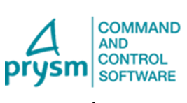 | UK and Sweden | Prysm Software develops and markets a convergent platform for centralized and proactive security, safety, and BMS management AppVision™. The openness of our platform offers each customer the possibility to customize & adapt it to their projects. The client thus has the level of autonomy he desires. »  www.prsym-software.com  T: +33 (0)4 42 97 14 97  E: commercial@prysm-software.com

 | UK and Sweden | Quanika  Adding new dimensions to security innovation. An efficient and flexible modern Access Control System to fulfil all your security needs.  www.quanika.com  Contact:  E: sales-eu@quanika.com
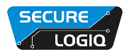 | UK and Sweden | Specialist Server Technology for HD Surveillance  With over 100 years of experience in IT and IP CCTV, Secure Logiq are the industry’s leading independent manufacturer of IT hardware optimised for HD surveillance applications. Our range consists of the industry’s highest throughput and highest storage density servers, award-winner analytics Optimised Servers and our VMS optimised client machines.  www.securelogiq.com  Contact:  T: +44 (0) 20 3475 5743  E: r.hughes@securelogiq.com
 | Sweden | Sensative AB  Yggio acts as a real-time integration layer between services and connected assets, sensors and networks, enabling multiple users and services to use data generated by both shared and private IoT devices. Enterprises, cities, municipalities, property owners, service partners, and more use the Yggio capabilities to rapidly deliver new services and applications.  www.sensative.com  Contact:  E: Info@sensative.com

 | UK and Sweden | The Siemon Company  Siemon is an industry leader in the design and manufacture of high quality, high performance IT infrastructure solutions and services for Data Centres, Intelligent Buildings and Enterprise LANs. Established in 1903, Siemon has led the way in innovation around Copper and Fibre cabling systems and works with more than 80% of the worlds G500 companies to enhance their journey into digital transformation.  Contact:  James Kiriamit  Marketing & Partner Manager EMEA  E: james_Kiriamiti@siemon.com  T: +44 (0) 1932 757 088
 | UK and Sweden | Siklu was founded with a goal to develop, build and delivery the best mmWave wireless connectivity radios on the plant bringing high speed Gigabit connectivity to the world Our technology brings scalability, multi-gigabit capacity and reliability to the world of wireless networks, and we are dedicated to delivering great value through fast-and-easy-to-deploy solutions that deliver flawless, predictable performance.  Contact:  T: +972 72 2454100  E: hello@siklu.com
 | UK and Sweden | Come right in! We realise the vision of the keyless world  More than 20 years ago, we paved the way with a revolutionary idea of digital locking technology. Today, we are still pursuing new ideas daily and continuously developing our product portfolio. Our heart beats for our customers, employees and partners. And for the technology with which we pursue our vision of the keyless world.  Contact:  T: +44 113 2515 036  E: uk@simons-voss.co.uk
 | UK and Sweden | Audio Analytics for Professionals, Best-in-class Sound Detection for Security and Healthcare  Sound Intelligence patented sound classification solutions make security monitoring systems proactive, enabling early detection of potential incidents, swift intervention, and in many cases, prevention of further escalation. Our technology has been deployed in thousands of applications around the world including prisons, healthcare institutes, schools, public transportation and convenience stores.  Contact:  www.soundintel.com/contact-us/
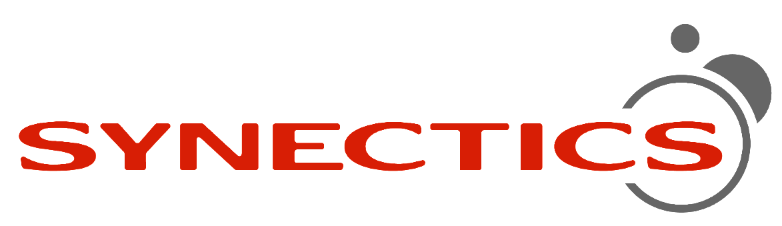 | UK and Sweden | Comprehensive Protection and Peace of Mind  Synectics design integrated end-to-end surveillance control systems for the world’s most demanding security environments. We excel at complex projects that require innovative, tailored solutions with high reliability and flexibility, specifically for casinos, oil and gas, marine, public space, banking, transport and critical infrastructure applications.  www.synecticsglobal.com  Contact:  T: +44 (0)114 255 2509  E: sales@synecticsglobal.com
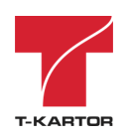 | UK and Sweden | Finding your way  T-Kartor creates and maintains geographical information, maps and charts. We develop solutions to deliver data, information and products in innovative ways.  Contact:  Christer Pihl  T: +46 733 206 819  E: Christer.pihl@t-kartor.com

 | Sweden | Cloud-based access control  Telcred provides a smart, cloud-based access control system for Axis Network Door controllers and wireless locks from SimonVoss and Assa Aperio. The combination of IP-connected door controllers and a cloud based, easy-to-integrate software with mobile access enables new business processes and business models in retail, real estate and infrastructure.  Contact:  Carlo Pompili, CEO  T: +46 (0)708 704 929  E: carlo@pompili@telcred.com
 | UK and Sweden | Total-Security is a security and software driven innovation company founded out of IT-Total in 2013. Our goal is to provide our customers with new solutions that helps them expand their business.  Without any history in the physical security market it is easy for us to see possibilities where others see problems. Our own experienced software developers are the key to our success, they enable us to create high quality applications and integrations at a high pace.  With the user in focus and our IT knowledge we can apply technology to create better experience than what are available today.  Contact:  T: +46 8 444 99 60  E: info@total-security.se
 | UK and Sweden | Ultinous real-time video analytics  Ultinous offers its video analytics services through its dedicated platform, UVAP. UVAP is a SDK-like set of software services that can be composed and extended in a flexible way to build scalable AI-based video capability and functionality.  Contact:  T+36 706 124 008  E: business@ultinous.com  www.ultinous.com

 | UK and Sweden | Licence plate recognition software  For the most demanding scenarios Vaxtor develop high performance products and solutions for license plate recognition in any scenario. Products in continuous evolution created on our technology OCR and specific solutions for any segment of the market. Complete LCR solutions for private access control, residential, road and urban security, traffic and special applications for embedded systems.  Contact:  T: +44 (0) 1707 808650  E: info.eu@vaxtor.com
 | UK | High Capacity Storage for ACS  Veracity manufacturers Transmission, Storage, Display and Command & Control Solutions. COLDSTORE is our low-power, high-capacity, video surveillance storage system. With a very low TCO, it is an ideal hard disc array for Axis Camera Station. ACS can also be integrated into our VIEWSCAPE Command and Control Security system integration platform.  www.veracityglobal.com  Contact:  T: +44 (0)1292 264967  E: sales@veracityglobal.com

